**Anjuman-I-Islam’s**

**M.H. SABOO SIDDIK POLYTECHNIC**

*8, Saboo Siddik Polytechnic Road, Byculla, Mumbai-400008*

**REPORT ON**

**“INTER-COLLEGE PROJECT EXHIBITION**

**& FRONTEND DESIGNING COMPETITION”**

The Project Exhibition Competition which took place on Friday, 15th March, 2024, a part of the grand Tech Fusion **State Level Event** hosted and organized by **Government Polytechnic, Thane,** saw the three prize-winners from the Diploma Computer department of M.H. Saboo Siddik Polytechnic of Engineering. The competition was a single day event held on 18th of March, and the participants included from diploma to degree programs across various technical departments of their respective institutes.

Total 40 students from the 3rd year of Computer Engineering department participated in Project Exhibition and 5 students participated in Frontend Designing Competition. The first place in project exhibition was secured by the project titled “**3D Outfit Customizer**,” consisting of team members **Abdurrahman Qureshi, Oaish Qazi, Shaikh Mohammed Hussain**. In Frontend Designing Competition, the first place was secured by **Oaish Qazi** andthe runner-up position was secured by **Abdurrahman Qureshi.** Our project was **Guided** **by** **Mr. Mohammed Ali & Frontend Designing was Guided by Mr. Khan Mohammed Zaid**. As a token of appreciation and hard work, the first prize winner has been awarded a cash prize of Rs. 700 along with Certificate, while the runner up has received a cash prize of Rs. 400 and Certificate. And all the other participants received the E-Certificate of participation.

The Event was sponsored by

* **Mr. M.Bhaskar, Managing Director, Infimind Institute of Skill Development Pvt Ltd.**
* **Mr. Rajan Shukla, Director, V2V Edtech LLP**
* **Mr. Vipul Alimkar, Proprietor, Alimkar Scoop & Cakes**
* **Mr. Mohan Kamath, Partner, SMG Consulting & Training**

   

1st Prize [Project Exhibition]:

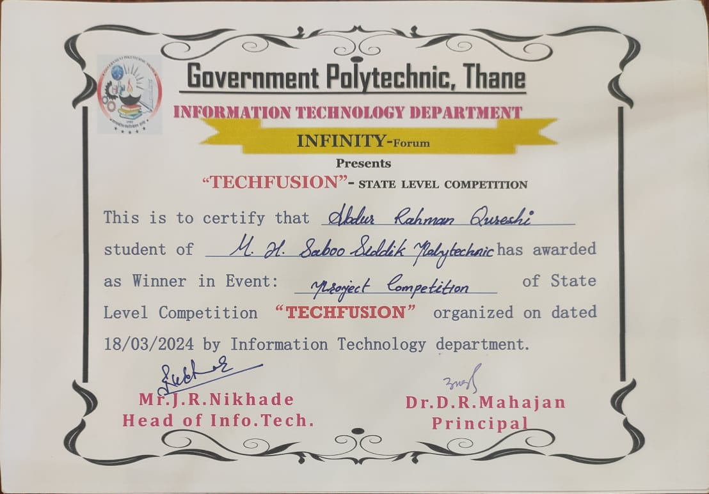

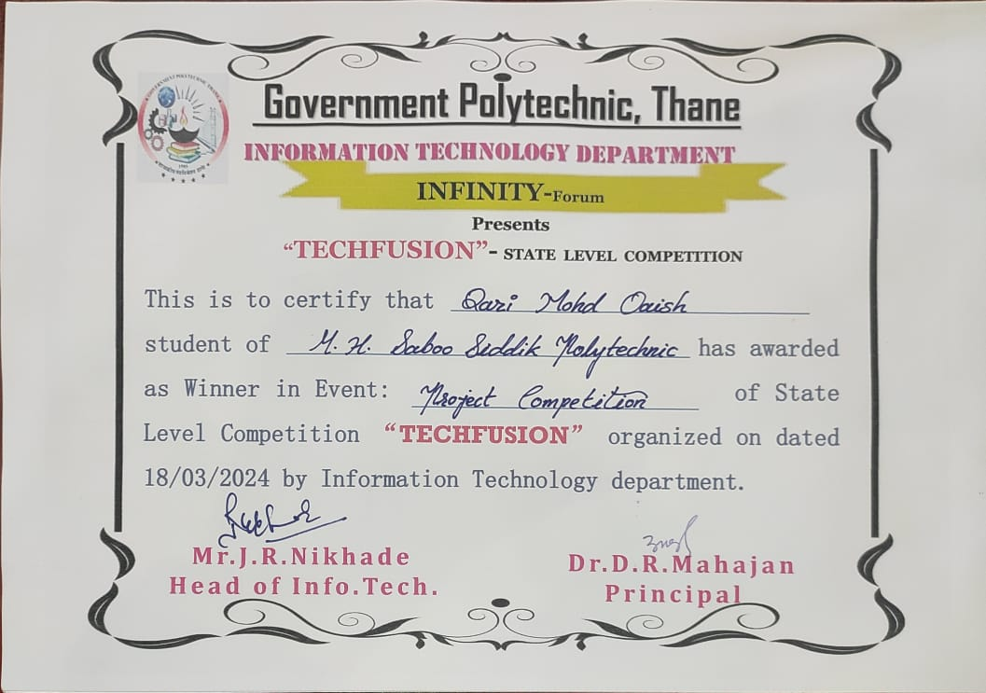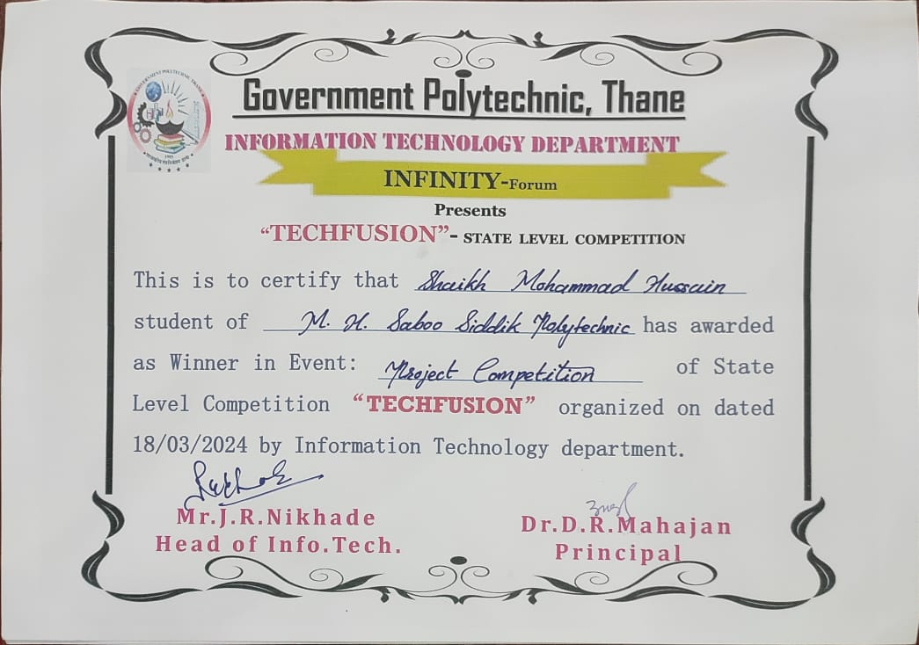

1st Prize [Frontend Designing]:

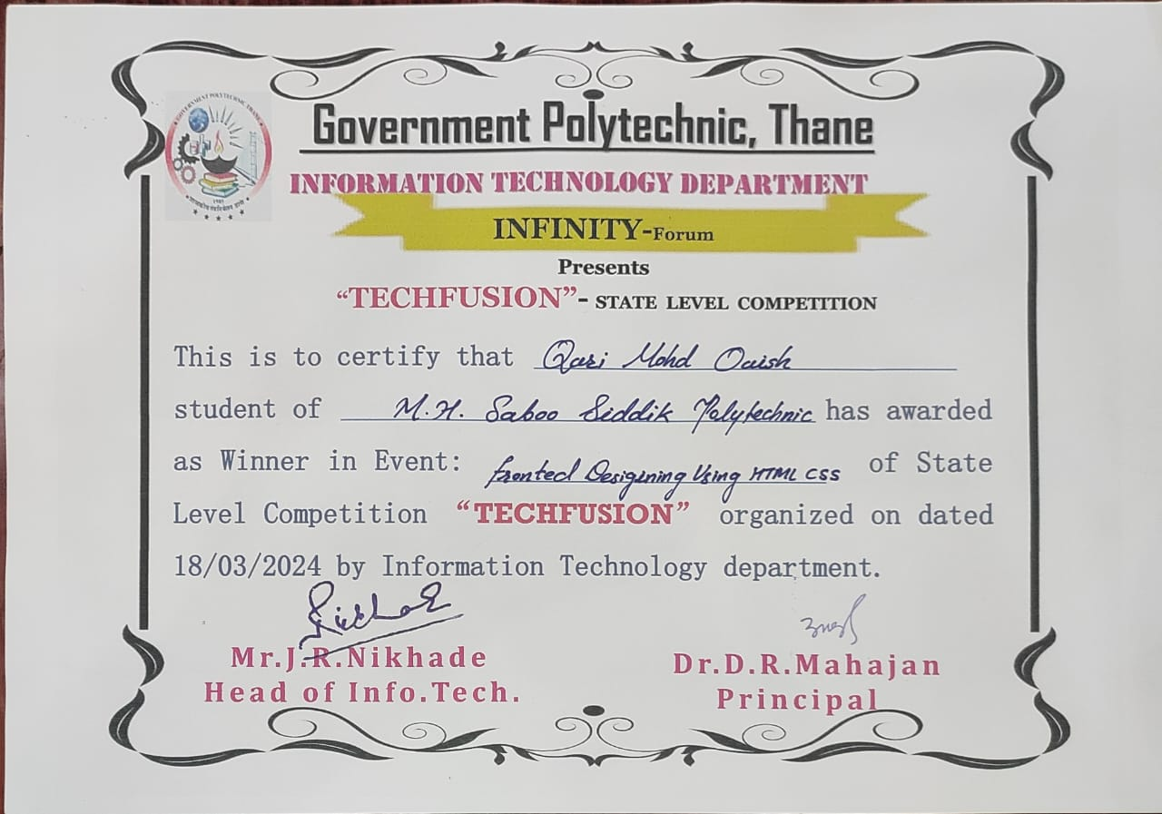

2nd Prize [Frontend Designing]:

